ENTRANCE TEST

MPHIL IN PUBLIC POLICY

NAME:__________
REGISTRATION NUMBER:_________

Name: _____________
Date of birth: _____________

Date test taken: _____________

Candidate’s signature: _____________
INSTRUCTIONS:
- You have 2 HOURS to complete this test.
- Do not start until told to do so by the test invigilator.
- Make sure you have written your Name on the COVER of this test booklet.
- The test is divided into 4 sections verbal comprehension, quantitative, analysis & reasoning and short answers.
- Remember to pace yourself to keep in tune with the test time.
- Please stop when you are asked to do so by the test invigilator.
- After completion of the test, you are required to submit the entire test booklet to the test invigilator.
- Usual exam conducting ethics will be observed during the test.

Section A
Verbal Comprehension

Following is an abridged version of the Nobel Lecture given by Muhammad Yunus (Grameen Bank) on December 10, 2006 after winning the Nobel Peace Prize. Read the text carefully and summarize it in your own words. What do you think is the main message of the speech? (Please restrict your answer to 500 words)

Your Majesties, Your Royal Highnesses, Honorable Members of the Norwegian Nobel Committee, Excellencies, Ladies and Gentlemen,
Grameen Bank and I are deeply honoured to receive this most prestigious of awards. We are thrilled and overwhelmed by this honour. Since the Nobel Peace Prize was announced, I have received endless messages from around the world, but what moves me most are the calls I get almost daily, from the borrowers of Grameen Bank in remote Bangladeshi villages, who just want to say how proud they are to have received this recognition.
Nine elected representatives of the 7 million borrowers-cum-owners of Grameen Bank have accompanied me all the way to Oslo to receive the prize. I express thanks on their behalf to the Norwegian Nobel Committee for choosing Grameen Bank for this year's Nobel Peace Prize. By giving their institution the most prestigious prize in the world, you give them unparalleled honour. Thanks to your prize, nine proud women from the villages of Bangladesh are at the ceremony today as Nobel laureates, giving an altogether new meaning to the Nobel Peace Prize.
All borrowers of Grameen Bank are celebrating this day as the greatest day of their lives. They are gathering around the nearest television set in their villages all over Bangladesh, along with other villagers, to watch the proceedings of this ceremony.
This years' prize gives highest honour and dignity to the hundreds of millions of women all around the world who struggle every day to make a living and bring hope for a better life for their children. This is a historic moment for them.

Poverty is a Threat to Peace
Ladies and Gentlemen:
By giving us this prize, the Norwegian Nobel Committee has given important support to the proposition that peace is inextricably linked to poverty. Poverty is a threat to peace.
World's income distribution gives a very telling story. Ninety four percent of the world income goes to 40 percent of the population while sixty percent of people live on only 6 per cent of world income. Half of the world population lives on two dollars a day. Over one billion people live on less than a dollar a day. This is no formula for peace.
The new millennium began with a great global dream. World leaders gathered at the United Nations in 2000 and adopted, among others, a historic goal to reduce poverty by half by 2015. Never in human history had such a bold goal been adopted by the entire world in one voice, one that specified time and size. But then came September 11 and the Iraq war, and suddenly the world became derailed from the pursuit of this dream, with the attention of world leaders shifting from the war on poverty to the war on terrorism. Till now over $ 530 billion has been spent on the war in Iraq by the USA alone.
I believe terrorism cannot be won over by military action. Terrorism must be condemned in the strongest language. We must stand solidly against it, and find all the means to end it. We must address the root causes of terrorism to end it for all time to come. I believe that putting resources into improving the lives of the poor people is a better strategy than spending it on guns.

Poverty is Denial of All Human Rights
Peace should be understood in a human way − in a broad social, political and economic way. Peace is threatened by unjust economic, social and political order, absence of democracy, environmental degradation and absence of human rights.
Poverty is the absence of all human rights. The frustrations, hostility and anger generated by abject poverty cannot sustain peace in any society. For building stable peace we must find ways to provide opportunities for people to live decent lives.
The creation of opportunities for the majority of people − the poor − is at the heart of the work that we have dedicated ourselves to during the past 30 years.
[…]

We Can Put Poverty in the Museums
I believe that we can create a poverty-free world because poverty is not created by poor people. It has been created and sustained by the economic and social system that we have designed for ourselves; the institutions and concepts that make up that system; the policies that we pursue.
Poverty is created because we built our theoretical framework on assumptions which under-estimates human capacity, by designing concepts, which are too narrow (such as concept of business, credit- worthiness, entrepreneurship, employment) or developing institutions, which remain half-done (such as financial institutions, where poor are left out). Poverty is caused by the failure at the conceptual level, rather than any lack of capability on the part of people.
I firmly believe that we can create a poverty-free world if we collectively believe in it. In a poverty-free world, the only place you would be able to see poverty is in the poverty museums. When school children take a tour of the poverty museums, they would be horrified to see the misery and indignity that some human beings had to go through. They would blame their forefathers for tolerating this inhuman condition, which existed for so long, for so many people.
A human being is born into this world fully equipped not only to take care of him or herself, but also to contribute to enlarging the well being of the world as a whole. Some get the chance to explore their potential to some degree, but many others never get any opportunity, during their lifetime, to unwrap the wonderful gift they were born with. They die unexplored and the world remains deprived of their creativity, and their contribution.
Grameen has given me an unshakeable faith in the creativity of human beings. This has led me to believe that human beings are not born to suffer the misery of hunger and poverty.
To me poor people are like bonsai trees. When you plant the best seed of the tallest tree in a flower-pot, you get a replica of the tallest tree, only inches tall. There is nothing wrong with the seed you planted, only the soil-base that is too inadequate. Poor people are bonsai people. There is nothing wrong in their seeds. Simply, society never gave them the base to grow on. All it needs to get the poor people out of poverty for us to create an enabling environment for them. Once the poor can unleash their energy and creativity, poverty will disappear very quickly.
Let us join hands to give every human being a fair chance to unleash their energy and creativity.
Ladies and Gentlemen,
Let me conclude by expressing my deep gratitude to the Norwegian Nobel Committee for recognizing that poor people, and especially poor women, have both the potential and the right to live a decent life, and that microcredit helps to unleash that potential.
I believe this honor that you give us will inspire many more bold initiatives around the world to make a historical breakthrough in ending global poverty.
Thank you very much.

Yunus, Muhammad. “Nobel Lecture.” NobelPrize.org. Oslo, December 10, 2006.
Find the full speech at: https://www.nobelprize.org/nobel_prizes/peace/laureates/2006/yunus-lecture-en.html

Section B
Quantitative

1) Evaluate
$$\frac{7 ×2^{13 }-2 × 2^{9}}{2 × 2^{9}}$$

2) Factorize completely
5ax – 5a² – 2x+ 2a

3) Which of the following is equal to (7⁻⁴ x 7⁸)¹⁰?

(A) 49⁻³²⁰ (B) 7⁴⁰ (C) 7⁻⁴⁰ (D) 49³²⁰

4) Carla bought a piece of ribbon that measured 1 meter in length.
She used 1/4 of the ribbon on a gift box.
She used 1/8 of the ribbon to make a bow.
What fraction of her ribbon was left?

(A) 1/32 (B) 12/32 (C) 5/8 (D) 3/8

5) At sunrise, the outside temperature was 1° below zero. By lunch time, the temperature rose by 17° and then fell by 4° by night. What was the temperature at the end of the day?

(A) 14º (B) 13º (C) 21º (D) 12º

6) If the sum of squares of three consecutive integers is 194, find the integers?

7) A fence post in Tina's garden is 4 feet tall.
When she measured the fence post’s shadow, she found that it was 12 feet long.
A tree in Tina’s yard had a shadow of 72 feet.
How tall is the tree?

(A) 24 (B) 68 (C) 60 (D) 88

8) Find the distance from P to Q:

9) A and B together have Rs. 1210. If of A's amount is equal to of B's amount, how much amount does B have?

(A) 460 (B) 550 (C) 664 (D) 484

10) Factorize completely
4x² – 25y²

11) At a party the ratio of boys to girls is 5: 4.
There are 40 boys at the party.
Find the total number of children at the party.

12) The profits of a company were $5 million in 2009 and $8 million in 2010.
Find the percentage increase in profits from 2009 to 2010.

13) If $\frac{x-1}{3}$ = k and k = 3, what is the value of x?
- 2
- 4
- 9
- 10

14) For i = −1 , what is the sum (7 + 3i) + (−8 + 9i) ?
- −1 + 12i
- −1 − 6i
- 15 + 12i
- 15 − 6i

Section C
Analysis & Reasoning

http://www.indiabix.com/logical-reasoning/logical-problems/

In question 1 and 2 each problem consists of three statements. Based on the first two statements, the third statement may be true, false, or uncertain.

1. Tanya is older than Eric.
Cliff is older than Tanya.
Eric is older than Cliff.
If the first two statements are true, the third statement is
- true
- false
- uncertain

2. | Blueberries cost more than strawberries.  Blueberries cost less than raspberries.  Raspberries cost more than strawberries and blueberries.  If the first two statements are true, the third statement is  - true  - false  - uncertain

http://www.indiabix.com/logical-reasoning/verbal-reasoning/
3. Find the statement that must be true according to the given information.

Erin is twelve years old. For three years, she has been asking her parents for a dog. Her parents have told her that they believe a dog would not be happy in an apartment, but they have given her permission to have a bird. Erin has not yet decided what kind of bird she would like to have.

- Erin's parents like birds better than they like dogs.
- Erin does not like birds.
- Erin and her parents live in an apartment.
- Erin and her parents would like to move.

http://www.indiabix.com/logical-reasoning/logical-games/030001

For questions 4 to 6 read the passage below carefully and answer the questions:

Five cities all got more rain than usual this year. The five cities are: Last Stand, Mile City, New Town, Olliopolis, and Polberg. The cities are located in five different areas of the country: the mountains, the forest, the coast, the desert, and in a valley. The rainfall amounts were: 12 inches, 27 inches, 32 inches, 44 inches, and 65 inches.

* The city in the desert got the least rain; the city in the forest got the most rain.
* New Town is in the mountains.
* Last Stand got more rain than Olliopolis.
* Mile City got more rain than Polberg, but less rain than New Town.
* Olliopolis got 44 inches of rain.
* The city in the mountains got 32 inches of rain; the city on the coast got 27 inches of rain.

4. Which city got the most rain?

a) Last Stand
b) Mile City
c) New Town
d) Olliopolis
e) Polberg

5. How much rain did Mile City get?

- 12 inches
- 27 inches
- 32 inches
- 44 inches
- 65 inches

6. Which city is in the desert?

- Last Stand
- Mile City
- New Town
- Olliopolis
- Polberg

For questions 7 and 8 read each definition and all four choices carefully, and find the answer that provides the best example of the given definition.

7. Applying for Seasonal Employment occurs when a person requests to be considered for a job that is dependent on a particular season or time of year. Which situation below is the best example of Applying for Seasonal Employment?

- The ski instructors at Top of the Peak Ski School work from December through March.
- Matthew prefers jobs that allow him to work outdoors.
- Lucinda makes an appointment with the beach resort restaurant manager to interview for the summer waitressing position that was advertised in the newspaper.
- Doug's ice cream shop stays open until 11 p.m. during the summer months.

8. Violating an Apartment Lease occurs when a tenant does something prohibited by the legally binding document that he or she has signed with a landlord. Which situation below is the best example of Violating an Apartment Lease?

- Qaiser has decided to move to another city, so he calls his landlord to tell him that he is not interested in renewing his lease when it expires next month.
- Amina recently lost her job and, for the last three months, has neglected to pay her landlord the monthly rent they agreed upon in writing when she moved into her apartment eight months ago.
- Zain writes a letter to his landlord that lists numerous complaints about the apartment he has agreed to rent for two years.
- Mary thinks that her landlord is neglecting the building in which she rents an apartment. She calls her attorney to ask for advice.

http://www.indiabix.com/verbal-reasoning/arithmetic-reasoning/

9. The total of the ages of Amar, Sidra and Mohid is 80 years. What was the total of their ages three years ago?

- 71 years
- 72 years
- 74 years
- 77 years

http://magoosh.com/gre/2012/gre-data-interpretation-practice-questions-pie-chart-and-bar-chart/

10.
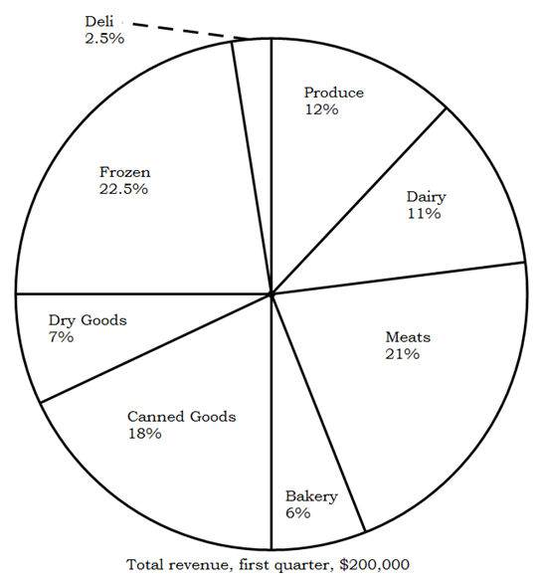

The pie chart above shows the breakdown of revenues for a particular grocery store over the first quarter of this year, what is the dollar amount of sales of canned goods in the first quarter of this year?

- $6,000
- $9,000
- $18,000
- $36,000
- $90,000

http://tests.practiceaptitudetests.com/practice/numerical-reasoning-tests/testnummember1#

Answer questions 11 to 14 based on the following graph that shows snowfall in cm for four different resorts from November to February.

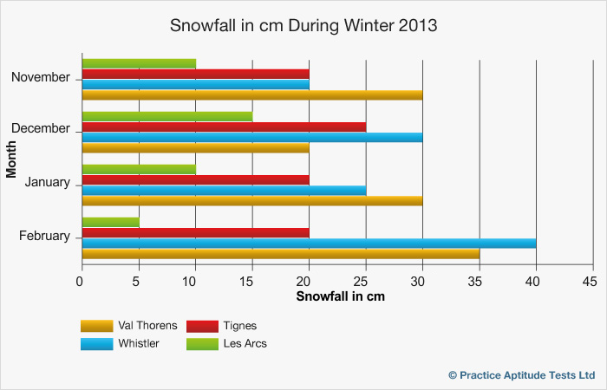
11. How much snow fell in Whistler and Les Arcs in December and February combined?
- 75 cm
- 80 cm
- 90 cm
- 105 cm

12. What was the percentage increase in snowfall in Whistler from November to January?
- 17%
- 20%
- 25%
- 50%

13. If total snowfall for March was predicted to increase by 20% from February in Val Thorens and Whistler and decrease by 15% in Tignes and Les Arcs, what would be the total snowfall across all the resorts in March?
- 85.5 cm
- 93.75 cm
- 111.25 cm
- 118.8 cm

14. Approximately what proportion of Val Thorens’ snowfall occurred in January?
- 26%
- 30%
- 31%
- 35%

Section D
Short Answers

Attempt the following questions in the space provided. Limit your answers to around 200-300 words.

1. Who is your favourite author? Describe a literary work of theirs and explain why this work holds importance for you.

2. What do you think is meant by the term “participatory governance”?

3. Respond to the following statement: Economic growth should be the government’s top priority in Pakistan.

